
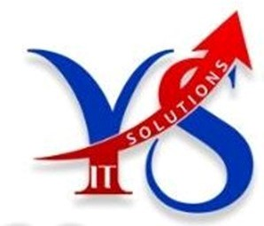

www.yakshaitsolutions.com

HR Interview Questions (Before Interview):
- Are you looking for job change?
Ans: Yes, I am looking for job change.
- Why are you looking for job change?
Ans: For better opportunity.
- What is your total Years of experience?
Ans: 5.8 Years.
- What is your relevant experience?
Ans: Relevant experience also same, I have experience in xxxxxxx only.
- For which company you’re working?
Ans: I am working for TCS Company.
- Is it permanent payroll?
Ans: No, I am working as a contract employee or Permanent employee with payroll company .
- What is your Payroll Company?
Ans: My payroll company is XXXXXXX
- What is your Notice period?
Ans: My Notice period is 30 days.
- Is it Negotiable?
Ans: Yes, upto 15 to20 Days.
- What is your current salary?
Ans: Currently I am getting xxxxx lakhs.
- What is your expected salary?
Ans: I am expecting xxxxx Lakhs.
- Is it negotiable?
Ans: Yes,

- What is Pancard Number?
Ans: Your Pancard number.
- What is Your Passport Number?
Ans: Your Passport Number.
- What is your Adhar Number?
Ans: your Adhar Number.
- Are you available for the interview tomorrow ?
Ans: Yes, I am available.
- At what time your available tomorrow?
Ans: Confirm with the institute.
- I am sharing the JD please look into it?
Ans: Sure.
- Do you have form-16 and PF Account?
Ans: I have Form-16 but I do not have PF in my Current payroll company.
- You can provide Form-16 once the interview is over?
Ans: yes, sure.

